LABORATORIYA ISHI-13

Mavzu: JavaScript eventlar bilan ishlash (click, submit, change)

1. Ishning maqsadi
Ushbu laboratoriya ishining maqsadi — JavaScript eventlar (click, submit, change) yordamida foydalanuvchi bilan interaktiv aloqani ta’minlash va Avia Kassa web-ilovasida ularning qo‘llanilishini nazariy va amaliy jihatdan o‘rganishdir.
- Event tushunchasini va turlarini o‘rganadi;
- Foydalanuvchi harakatlariga javob berish imkoniyatini tushunadi;
- “click”, “submit” va “change” eventlarining vazifasi va qo‘llanishini bilib oladi;
- Web-ilovada interaktiv chipta tanlash va buyurtma berish jarayonini boshqarish tamoyillarini o‘zlashtiradi.

2. Nazariy qism

2.1 Event (hodisa) tushunchasi
Event (hodisa) — foydalanuvchi yoki tizim tomonidan yuzaga keladigan harakat yoki voqea. Eventlar JavaScript orqali web-sahifaga interaktivlik qo‘shish imkonini beradi. Misol:
- Foydalanuvchi chipta kartasini bosadi (click);
- Buyurtma formasini yuboradi (submit);
- Tanlov (manzil yoki sana) o‘zgaradi (change).

2.2 Eventlarni boshqarish usullari
- HTML atributlari orqali: <div onclick="funksiya()">;
- DOM orqali: element.addEventListener("event", funksiya);
addEventListener afzalligi: bir elementga bir nechta event qo‘shish mumkin va kod toza bo‘ladi.

2.3 Eng ko‘p ishlatiladigan eventlar
- click – foydalanuvchi chipta kartasini bosganda natija ko‘rsatiladi.
- submit – foydalanuvchi buyurtma formasini yuboradi, ma’lumotlar tekshiriladi va tasdiqlash xabari beriladi.
- change – foydalanuvchi tanlov qilganda chipta kartalari filtrlanadi yoki yangilanadi.

2.4 Eventlarni boshqarish afzalliklari
- Web-sahifa interaktiv va qulay bo‘ladi;
- Foydalanuvchi harakatlariga real vaqt javob berish mumkin;
- Kod modular va boshqarilishi oson bo‘ladi;
- Dinamik kontent yaratish imkoniyati oshadi.

2.5 Xavfsizlik
- Foydalanuvchi kiritgan ma’lumotlarni tekshirish zarur;
- Submit yoki click eventlarida sanitizatsiya qilinmagan ma’lumot XSS hujumlariga olib kelishi mumkin;
- Zarur hollarda server-side tekshiruv bilan birga ishlatiladi.

3. Amaliy qism
<!DOCTYPE html>
<html lang="uz">
<head>
<meta charset="UTF-8">
<title>Avia Kassa – JS Eventlar</title>
<style>
body{
font-family:Arial;
background:#eef2f7;
margin:0;
}
header{
background:#1976d2;
color:white;
padding:15px;
text-align:center;
}
.container{
padding:20px;
}
select, button, input{
padding:8px;
margin:5px 0;
}
.tickets{
display:flex;
gap:20px;
flex-wrap:wrap;
}
.ticket{
background:white;
width:220px;
border-radius:8px;
box-shadow:0 4px 10px rgba(0,0,0,.2);
padding:10px;
text-align:center;
cursor:pointer;
}
.ticket img{
width:100%;
height:120px;
object-fit:cover;
}
#output{
margin-top:20px;
background:white;
padding:15px;
border-radius:8px;
}
</style>
</head>
<body>
<header>
✈️ Avia Kassa (JS Eventlar)
</header>
<div class="container">
<h3>Manzil tanlang:</h3>
<select id="destination">
<option value="all">Barchasi</option>
<option value="moskva">Toshkent → Moskva</option>
<option value="istanbul">Toshkent → Istanbul</option>
<option value="dubay">Toshkent → Dubay</option>
</select>
<div class="tickets" id="ticketList"></div>
<div id="output">
<h3>🛫 Tanlangan chipta</h3>
</div>
<h3>📦 Buyurtma berish</h3>
<form id="orderForm">
<input type="text" placeholder="Ismingiz" required>
<button type="submit">Yuborish</button>
</form>
</div>
<script>
let tickets = [
{from:"Toshkent", to:"Moskva", date:"25/12/2025", price:250, img:"https://images.unsplash.com/photo-1507842217343-583bb7270b66"},
{from:"Toshkent", to:"Istanbul", date:"26/12/2025", price:180, img:"https://images.unsplash.com/photo-1495446815901-a7297e633e8d"},
{from:"Toshkent", to:"Dubay", date:"27/12/2025", price:300, img:"https://images.unsplash.com/photo-1516979187457-637abb4f9353"}
];

let ticketList = document.getElementById("ticketList");
let outputDiv = document.getElementById("output");
let destination = document.getElementById("destination");
// Click event – chipta tanlash
function showTickets(filter){
ticketList.innerHTML="";
tickets.forEach((ticket, index)=>{
if(filter==="all" || ticket.to.toLowerCase()===filter){
let div=document.createElement("div");
div.className="ticket";
div.innerHTML=`
<img src="${ticket.img}">
<h4>${ticket.from} → ${ticket.to}</h4>
<p>Sanasi: ${ticket.date} | Narx: ${ticket.price}$</p>
`;
div.addEventListener("click",()=>{
outputDiv.innerHTML=`<h3>🛫 Tanlangan chipta</h3>
<p><b>${ticket.from} → ${ticket.to}</b></p>
<p>Sanasi: ${ticket.date}</p>
<p>Narxi: ${ticket.price}$</p>`;
});
ticketList.appendChild(div);
}
});
}
// Change event – manzil tanlash
destination.addEventListener("change", ()=>{
showTickets(destination.value);
});
// Submit event – buyurtma yuborish
document.getElementById("orderForm").addEventListener("submit", (e)=>{
e.preventDefault();
alert("Buyurtmangiz qabul qilindi!");
outputDiv.innerHTML="<h3>🛫 Tanlangan chipta</h3>";
document.getElementById("orderForm").reset();
});
// Boshlanishida barcha chiptalar chiqadi
showTickets("all");
</script>

</body>
</html>

4. Natija
- Foydalanuvchi interaktiv tarzda chipta tanlay oladi.
- Tanlangan chipta ma’lumotlari real vaqt rejimida output bo‘limida ko‘rsatiladi.
- Manzil bo‘yicha filtrlash (change) ishlaydi.
- Buyurtma yuborish (submit) eventi orqali foydalanuvchi ma’lumotlari tekshiriladi va tasdiqlash xabari beriladi.
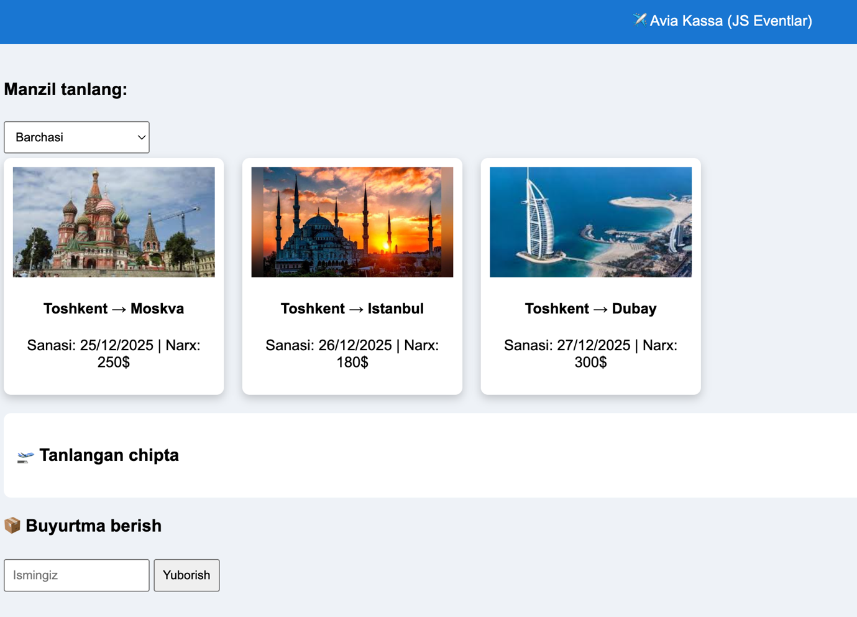

5. Xulosa
Ushbu laboratoriya ishida JavaScript eventlari (click, submit, change) Avia Kassa loyihasi misolida amaliy tarzda o‘rganildi. DOM elementlarini yaratish va ularni eventlar bilan boshqarish foydalanuvchiga qulay interaktiv web-sahifa yaratishga imkon berdi. Shu sababli, eventlarni to‘g‘ri qo‘llash real web-ilovalarda foydalanuvchi tajribasini yaxshilash va tizimning ishlash samaradorligini oshirish uchun zarur ko‘nikma ekanligi aniqlandi.

